**Worksheet – 1.3**

**Student Name:** Vivek Kumar  **UID:** 21BCS8129

**Branch:** BE-CSE (LEET) **Section/Group:** 809/A

**Semester:** 4th **Date of Performance:** 17/03/2022

**Subject Name:** Programming in Python Lab  **Subject Code:** 20CSP-259

**1. Aim/Overview of the practical:**

1. Write a python program to calculate area of 10 different circles. Given the pie = 22/7 and radius of the circles entered by user using Simple Function, Parameterized Function, Return Type with function and return type with parameterized Functions.
2. Write a python program to print Multiplication tables from 2 to 20 whether table values entered by user using Simple Function, Parameterized Function, Return Type with function and return type with parameterized Functions.

**2. Task to be done/ Which logistics used:**

1. Find area of Circle using different types of method.
2. Calculate the Multiplication table of 2 to 20 using different types of method.

**3. Steps for experiment/practical/Code:**

1. Find area of Circle using different types of method.

**Sourse Code:**

*# Pi value initialization globally*

pi=22/7

def areacir(n):

ar = pi*(n**2)

return ar

*# Simple Function*

def area7():

a = float(input('Enter Radious 7: '))

ar7 = pi*(a**2)

print("Area 7 = ",ar7,"cm^2")

*# Return Type with function*

def area8():

b = float(input('Enter Radious 8: '))

ar8 = pi*(b**2)

return ar8

*# Parameterized Function*

def area9(c):

ar9 = pi*(c**2)

print("Area 9 = ",ar9,"cm^2")

*# Return type with parameterized Functions*

def area10(d):

ar10 = pi*(d**2)

return ar10

*#main function*

def circle():

print('Area of 10 circle is as follows: ')

for i in range(1,7):

n = float(input('Enter Radious {}: '.format(i)))

area = areacir(n)

print("Area {0} = {1} cm^2".format(i,area))

*# Simple Function call*

area7()

*# Return Type with function call*

ar8 = area8()

print("Area 8 = ",ar8,"cm^2")

*# Parameterized Function call*

c = float(input('Enter Radious 9: '))

area9(c)

*# Return type with parameterized Functions call*

d = float(input('Enter Radious 10: '))

ar10 = area10(d)

print("Area 10 = ",ar10,"cm^2")

*#main function call*

circle()

1. Calculate the Multiplication table of 2 to 20 using different types of method.

**Sourse Code:**

*# Parameterized Function*

def table(num):

*# For range 2 to 20 according to the question*

for i in range(2,20+1):

print(num,' x ', i, ' = ',num*i)

num = int(input('Enter the Number: '))

*# Parameterized Function call*

table(num)

**4. Result/Output/Writing Summary:**

1. Find area of Circle using different types of method.

**Output:**

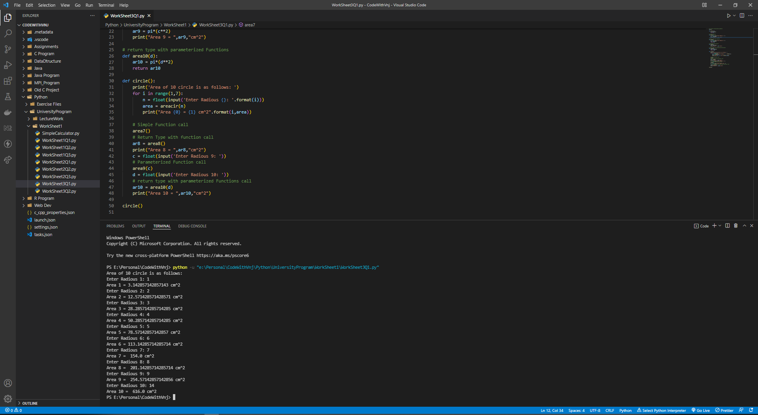

1. Calculate the Multiplication table of 2 to 20 using different types of method.

**Output:**

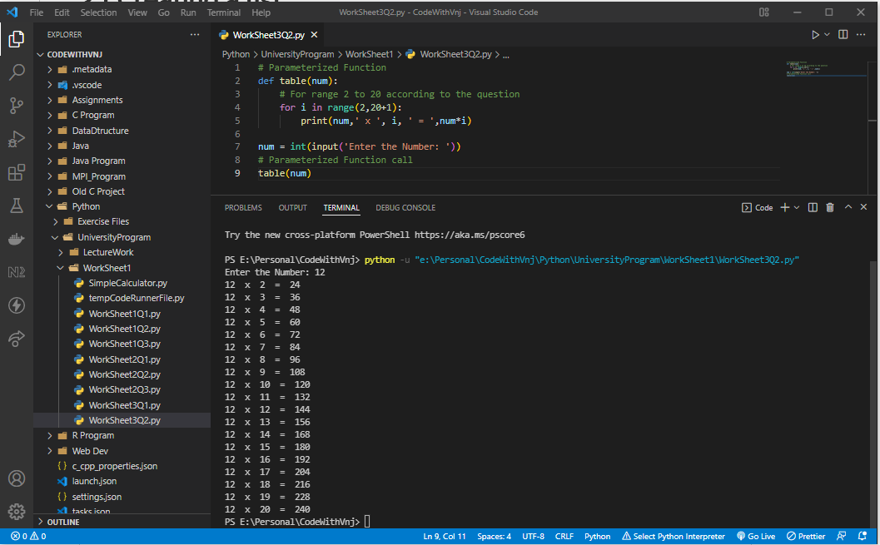

**Learning outcomes (What I have learnt):**

**1.** I have learnt, how to find Armstrong Number.

**2.** Learnt to find the Palindrome number.

**3.** Learnt to find the Largest number.

**Evaluation Grid (To be created as per the SOP and Assessment guidelines by the faculty):**

|  |  |  |  |
| --- | --- | --- | --- |
| Sr. No. | Parameters | Marks Obtained | Maximum Marks |
| 1. |  |  |  |
| 2. |  |  |  |
| 3. |  |  |  |
| 4 |  |  |  |